## **Assignment: Installing XAMPP, PHP, and Making Your First Site Live on Localhost**

**Objective:**

This lab will guide you through the process of installing XAMPP, setting up PHP, and making your first PHP website live on `localhost`. By the end of this lab, you'll have your local server running with a simple PHP website.

**Part 1: Installing XAMPP**

1. Download XAMPP

- Visit the [XAMPP official website](https://www.apachefriends.org/index.html).

- Download the version compatible with your operating system (Windows, Linux, or macOS).

In case you are not able to download it from the official site you can download it from following drive link.

<https://drive.google.com/file/d/1njKzhWcsH0BDVUl6qV5W3O8a1QYzTXbi/view?usp=sharing>

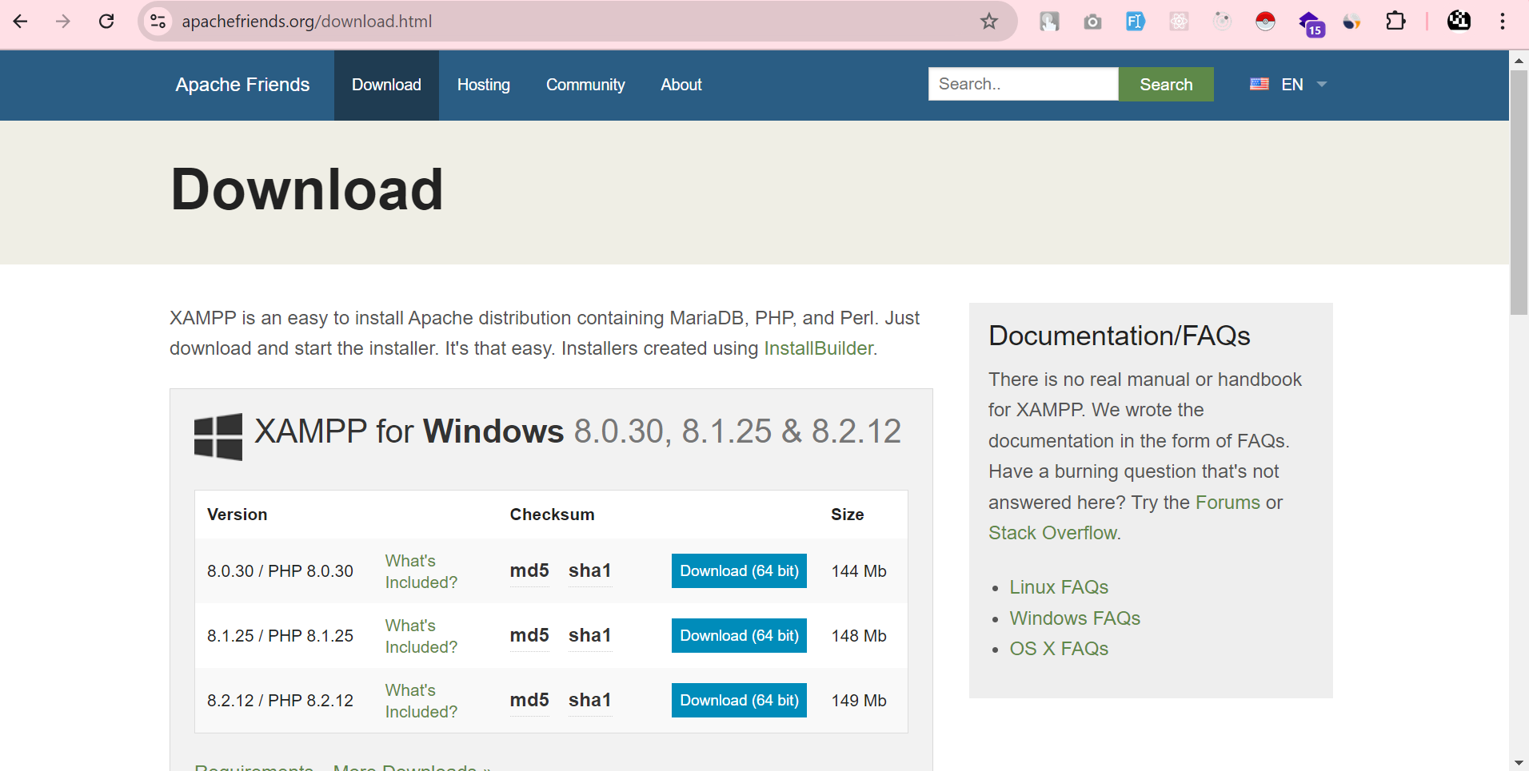

2. Run the XAMPP Installer

- After the download is complete, open the installer.

- You'll be greeted by a welcome screen. Click Next to proceed.

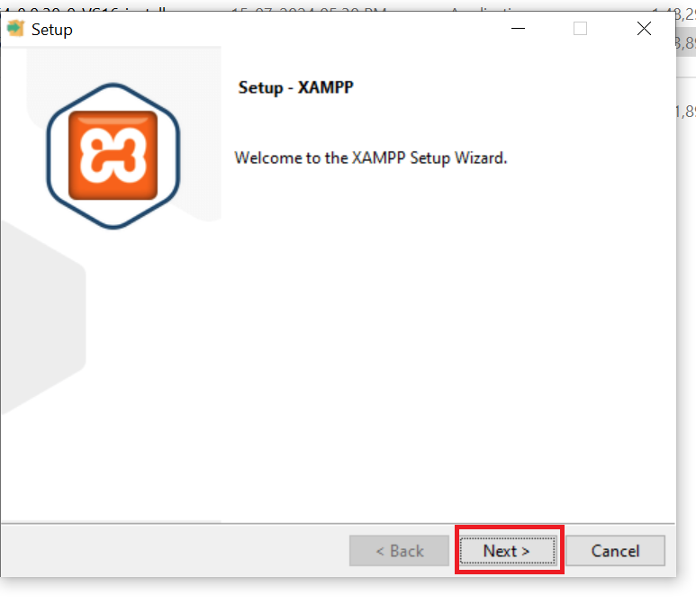

3. Select Components

- In the component selection screen, ensure Apache and PHP are selected. You can also select MySQL and other components depending on your needs.

- Click Next.

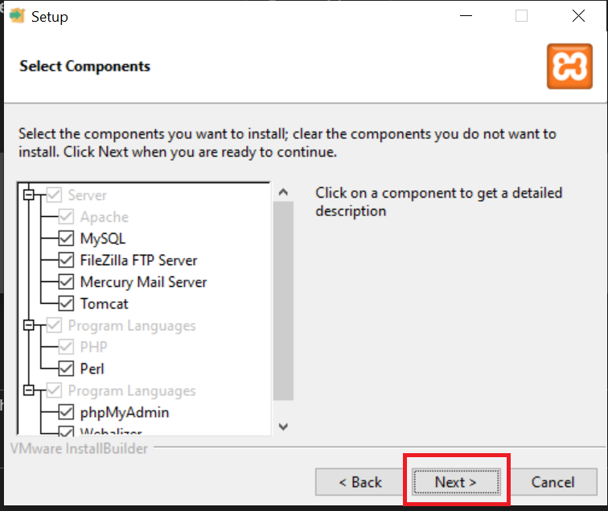

4. Choose Installation Folder

- Choose the directory where you want to install XAMPP (default is usually `C:\xampp` on Windows).

- Click Next.

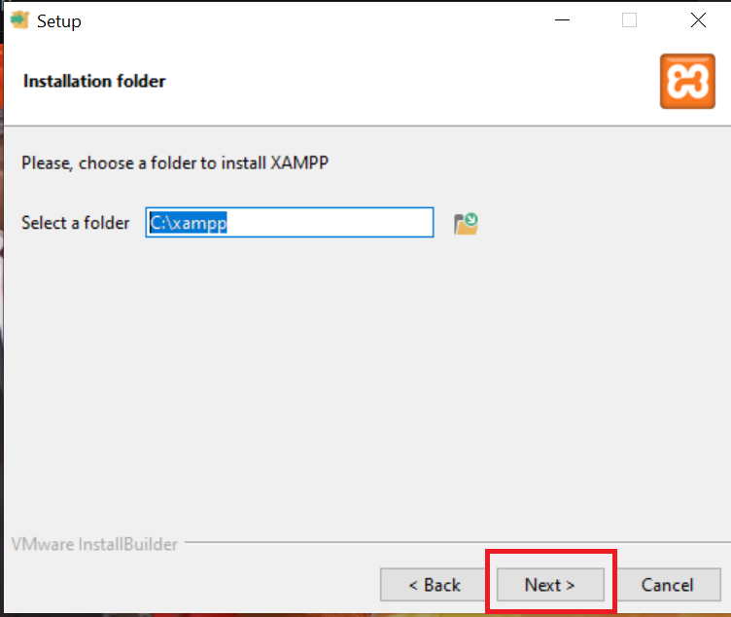

5. Complete Installation

- XAMPP will begin the installation process. Once completed, click Finish.

**Part 2: Starting Apache Server and PHP**

1. Open XAMPP Control Panel

- Launch XAMPP and open the Control Panel.

- Start the Apache service by clicking on the Start button next to Apache.

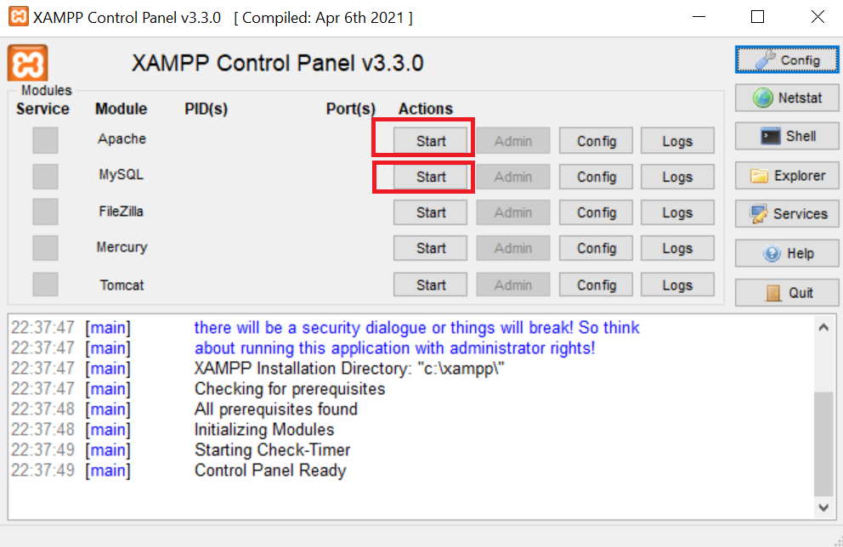

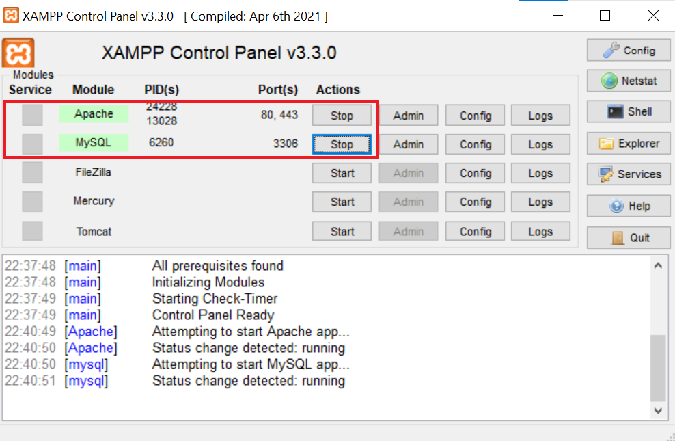

2. Check if Apache is Running

- Open your browser and go to `http://localhost/`. If XAMPP is installed correctly, you should see the XAMPP welcome page.

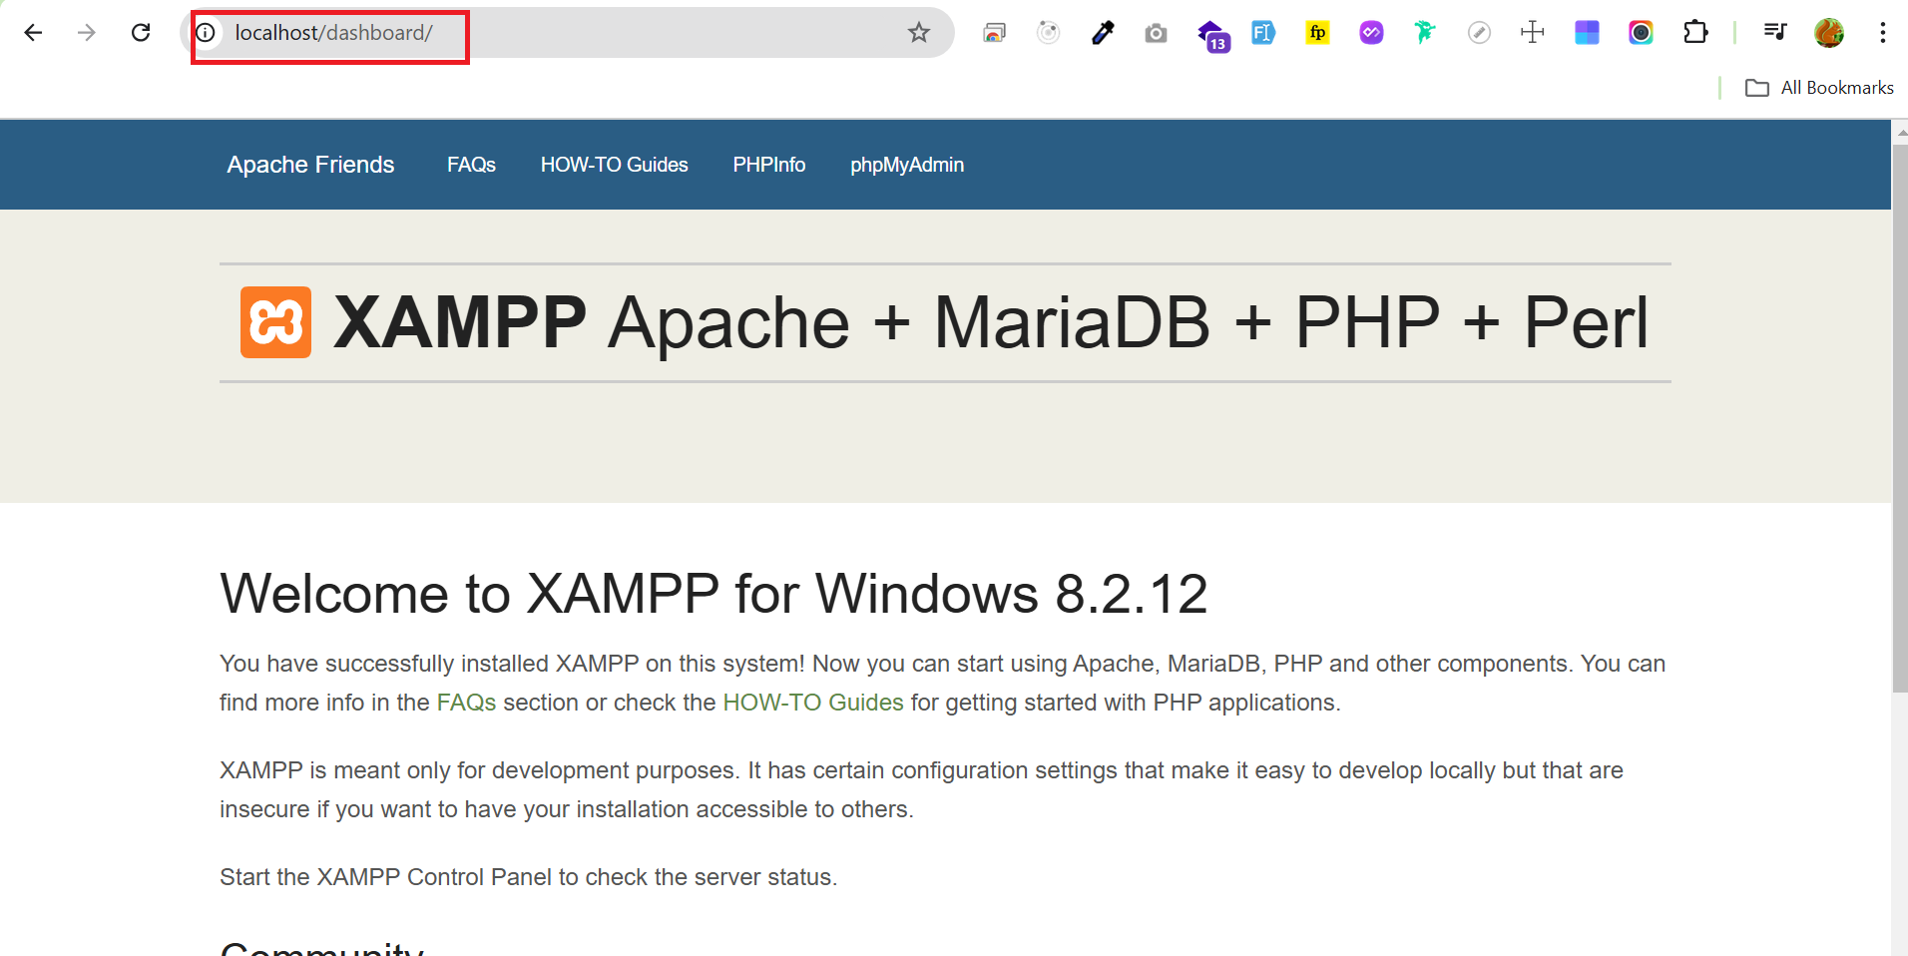

**Part 3: Setting Up Your First PHP Website**

1. Create a Project Folder

- Navigate to the XAMPP installation folder (`C:\xampp\htdocs` on Windows).

- Create a new folder for your website. For example, name it `myfirstsite`.

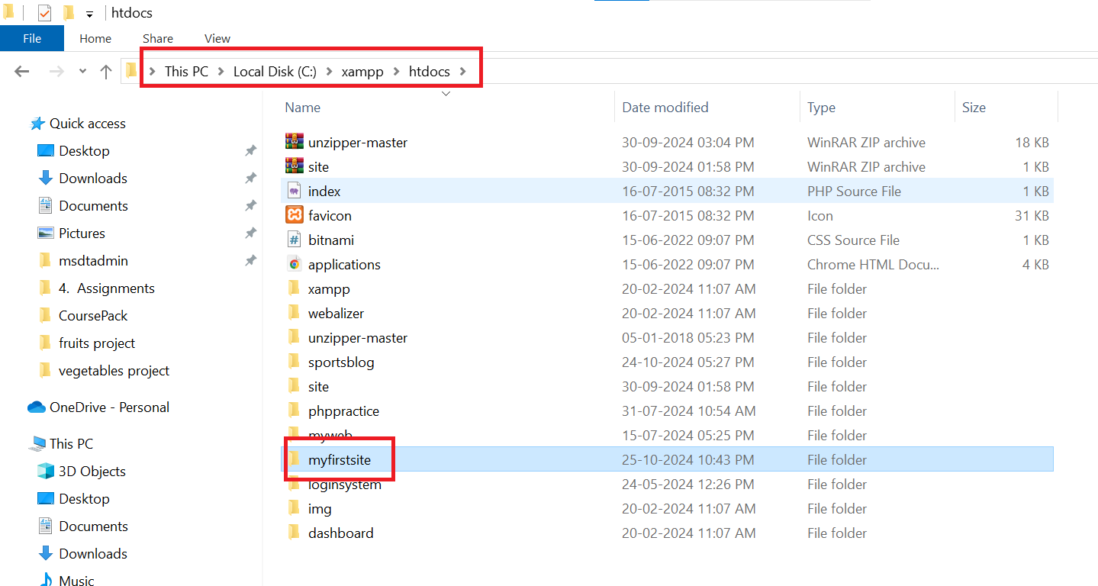

2. Create a PHP File

- Open a text editor (e.g., Notepad++) and create a new PHP file.

- Write the following code inside the file:

***<?php***

***echo "Hello, World! This is my first PHP site!";***

***?>***

- Save the file as `index.php` inside the `myfirstsite` folder.

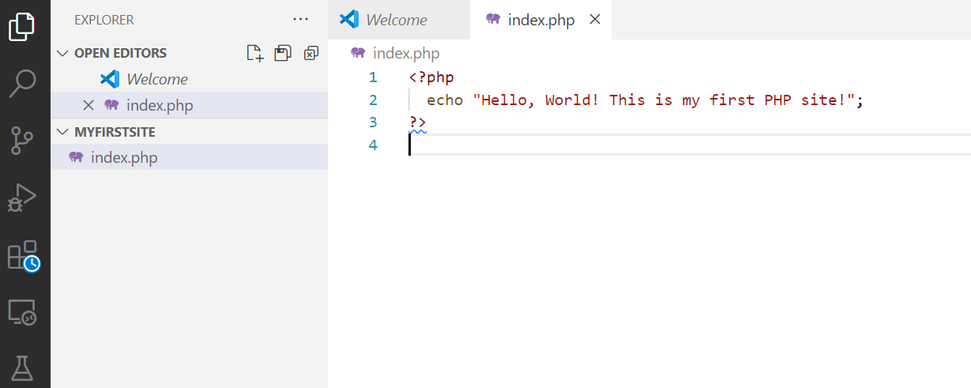

3. Access Your Site on Localhost

- Open your browser and go to `**http://localhost/myfirstsite/index.php**`.

- You should see the message: `Hello, World! This is my first PHP site!`

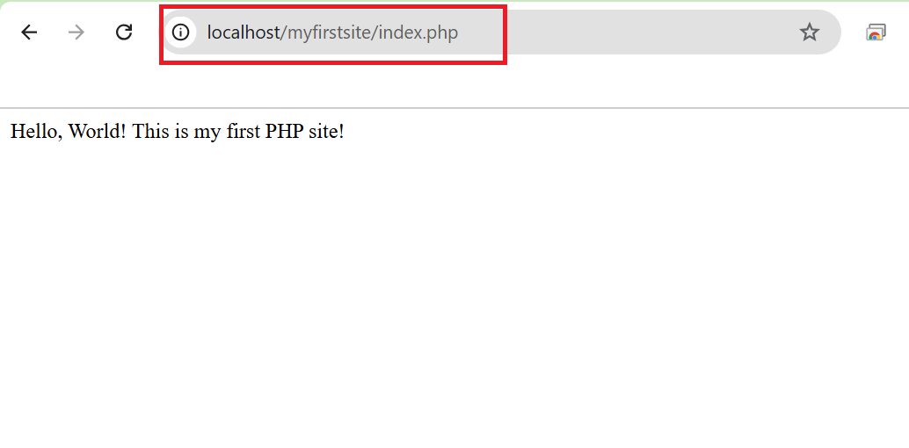

**Part 4: Testing PHP Functionality**

1. Add PHP Info Function

- You can test PHP functionality by adding the following code to your `index.php` file:

***<?php***

***phpinfo();***

***?>***

- Refresh your browser at `http://localhost/myfirstsite/index.php`.

- This will display all the PHP configuration details of your server.

